Ideation Phase
Brainstorm & Idea Prioritization

Date | 29-06-2026
Project Name | Automated Network Request Management
Team ID
Maximum Marks

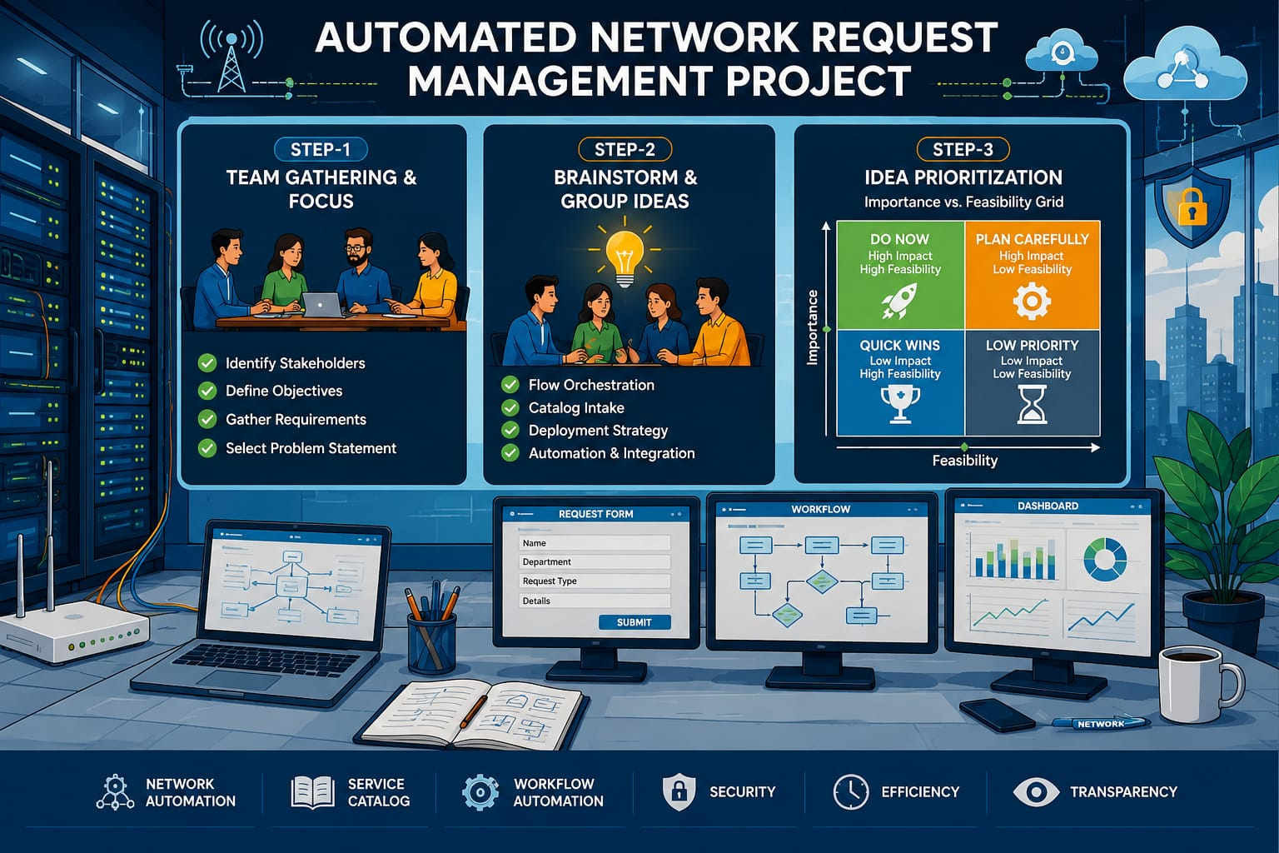

Step-1: Team Gathering, Collaboration and Select the Problem Statement

Problem Statement (How Might We)
How might we leverage ServiceNow to fully automate routine network request fulfillment (firewall rules, IPAM, VLAN provisioning) to reduce MTTR from days to minutes, eliminate manual configuration errors, and maintain an audit-ready CMDB?

Team Gathering
To successfully execute this end-to-end automation, our project team will consist of:
- Network Automation Engineers: To define configuration parameters and map API endpoints for target hardware/software (e.g., Firewalls, IPAM).
- ServiceNow Administrators/Developers: To build the catalog items, configure Flow Designer, and manage Integration Hub spokes.
- IT Security & Compliance Analysts: To define automated risk-assessment criteria and multi-level approval guardrails.
- UI/UX Designer / Business Analyst: To ensure the intake forms are clean, modern, and prevent user input errors.

Step-2: Brainstorm, Idea Listing and Grouping

Cluster 1: Catalog Intake & User Experience
- Create dedicated service catalog items for core network functions: Firewall Rule Modification, VLAN Provisioning, and IP Address (IPAM) Assignment.
- Implement dynamic UI policies to show/hide complex technical fields based on user selection (e.g., hiding advanced routing fields for standard users) to prevent information overload.
- Enforce strict upfront data validation (regex for IP addresses, dropdown subnets) to stop incomplete or corrupted data from entering the automation pipeline.

Cluster 2: Flow Orchestration, Approvals & Integration
- Configure automated workflow routing using Flow Designer to split requests into "Low-Risk" (auto-approved) and "High-Risk" (requiring CAB/Security sign-off) pathways.
- Utilize ServiceNow Integration Hub spokes to push approved configurations directly to network infrastructure via secure APIs.
- Enable closed-loop verification to test network connectivity post-execution and automatically update the CMDB before closing the ticket.
- Enforce immutable audit logging within the record to track requested parameters, approval stamps, and API execution logs for strict compliance.

Cluster 3: Quality Assurance & Deployment Strategy
- Perform isolated unit testing on individual Integration Hub actions and API payloads in a sub-production sandbox.
- Run end-to-end simulation testing using complex network edge cases (e.g., overlapping IP ranges, duplicate firewall rules) to validate error-handling scripts.
- Conduct User Acceptance Testing (UAT) with network operations (NetOps) and standard business users to refine form logic and notification clarity.
- Create a phased rollout plan starting with low-risk requests (e.g., simple IP allocations) before activating high-risk automation (e.g., core firewall adjustments).

Step-3: Idea Prioritization (Importance vs. Feasibility)
Priority Level | Idea / Task | Justification
High Importance, High Feasibility  (Do Now) | Build core catalog forms with strict data validation (IP formatting, mandatory fields). | Essential for capturing clean payload data; highly straightforward to implement using native ServiceNow variables.
High Importance, High Feasibility  (Do Now) | Configure standard conditional approval steps using Flow Designer. | Critical for governance and security compliance; utilizes out-of-the-box Flow Designer logic.
High Importance, Low Feasibility  (Plan Carefully) | Build and test Integration Hub API connections to network hardware. | Maximum business value (enables the actual automation), but requires extensive security clearance, credential mapping, and network access configuration.
High Importance, Low Feasibility  (Plan Carefully) | Implement closed-loop verification and automated CMDB updates. | Crucial for keeping infrastructure tracking accurate, but mapping post-execution data back into CI relationships requires careful architecture.
Low Importance, High Feasibility  (Quick Wins) | Set up automated email/Slack status notifications for end-users. | Very easy to configure via standard platform notifications; immediately improves visibility and user satisfaction.

